GroupUnion
- Display the name and the corresponding description based on the candidates salary (Use union and be cautious of the types) Order by name
< 50000 Honest
>50000 and < 100000 Not so honest
>100000 80000
SELECT fname || ' ' || lname AS "name", 'Honest' AS "description" FROM mendoza_candidate WHERE salary < 50000
UNION
SELECT fname || ' ' || lname AS "name", 'Not so honest' FROM mendoza_candidate WHERE salary > 50000 AND salary < 100000
UNION
SELECT fname || ' ' || lname AS "name", '80000' FROM mendoza_candidate WHERE salary > 100000
ORDER BY "name";

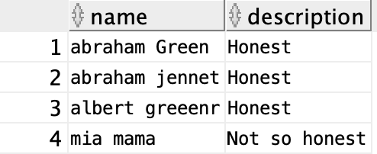
- Display the name and the corresponding description based on the candidates salary (Use a plain case statement in chapter 5)
< 50000 Honest
>50000 and < 100000 Not so honest
>100000 80000
SELECT FNAME||' '||LNAME AS "NAME", CASE WHEN SALARY < 50000 THEN 'Honest'
WHEN SALARY >50000 AND SALARY < 100000 THEN 'Not so honest'
WHEN SALARY >100000 THEN '800000'
END AS "DESCRIPTION"
FROM MENDOZA_CANDIDATE
ORDER BY 1;

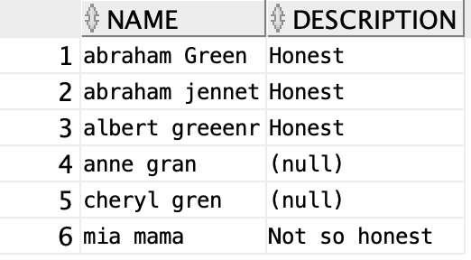
3) Display the name of all the people who are not associated with a party (use not in). This is a bit tricky because people who don’t have a party_id will have a null and you cannot compare a null using not in because it doesn’t know how to deal with non-data. You can put the party_id in an NVL function in the where clause to resolve this issue
SELECT CONCAT(fname,lname) as name FROM mendoza_candidate WHERE nvl(partyid, -1) NOT IN
(SELECT partyid from mendoza_party)

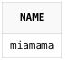
4) Repeat question 3 using (not exists)
SELECT CONCAT(fname,lname) AS name FROM mendoza_candidate WHERE NOT EXISTS
(SELECT partyid FROM mendoza_party WHERE mendoza_party.partyid = mendoza_candidate.partyid AND mendoza_candidate.partyid is not null);

5) Repeat question 3 using (minus)
Select CONCAT(fname,lname) as name from mendoza_candidate
MINUS
Select CONCAT(fname,lname) as name from mendoza_candidate where partyid IS NOT NULL;

